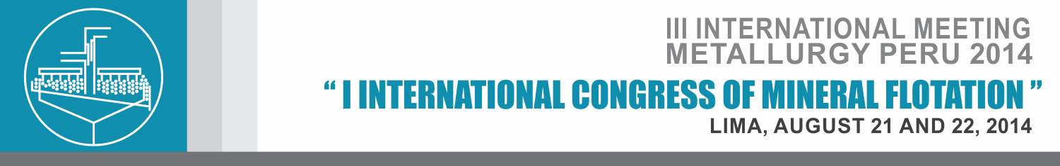
REGISTRATION FORM
PERSONAL DATA
Name
Last name
Country |  | City
Position
DNI / Passport
Email
CellPhone/ Telephone

BILLING DATA
Company Name
Mining Operation
Registered Name
RUC
Contact Person
Email
CellPhone/ Telephone

INVESTMENT
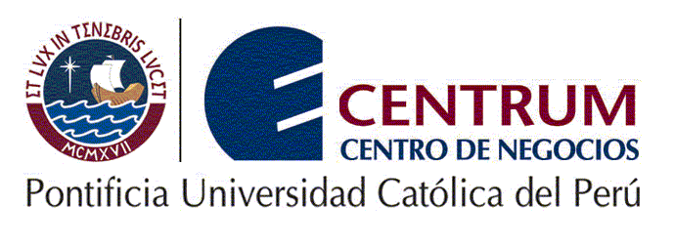
Duration: August 21st and 22nd, 2014
Venue: CENTRUM- CATOLICA
CATEGORY |  | INVESTMENT
Foreigner |  | 400 dollars
Authors |  | 199 dollars

TYPE OF PAYMENT
Deposit: | BANCO DE CREDITO DEL PERU
CardMolder: | INTERNATIONAL METALLURGICAL CONSULTANTS
Account Number in Dollars: | 193-1872625-1-12
Inter-bank code: | 00219300187262511219
SWIFTCode: BCPLPEPL | BCPLPEPL
INTERNAL CONTROL
Fecha de Inscripción |  | Tipo de Operación |  | Boleta / Factura
Fecha de Cancelación |  | Número de OP

